Power & Control Wheel
Domestic abuse may include physical and sexual violence, but those behaviors are rarely found without other forms of abuse. Verbal and emotional abuse, financial control, isolation, manipulation, threats, and intimidation are all common, though they may be more difficult to identify.

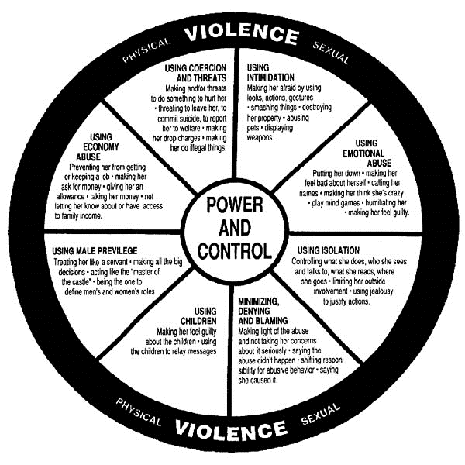
Original Power & Control Wheel Developed by:
Domestic Abuse Intervention Project
202 East Superior Street
Deluth, MN 55802

CYCLE OF VIOLENCE

Family Concerns
Cultural community
Promises
Denial
Fear

The theory of the Cycle of Violence was developed by Dr. Lenore Walker. It has three distinct phases which are generally present in violent relationships:
- Seduction/Making Peace - gifts, reconciliation, physical affection, attention, promises, or apologies. “I’m sorry.” “It won’t happen again.” “It will be different this time.”
- Tension Building - a period of increasing pressure, mood swings, irritability, demands, and emotional withdrawal. This phase may feel like “walking on eggshells.”
- Violation/Explosion - when the abusive outbursts occur – not always physical but extremely painful all the same. Promises are broken; threats are carried out.

